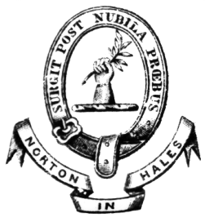

Annual Parish Meeting

The Annual Parish Meeting for the Parish of Norton in Hales will be held at the Jubilee Hall on Tuesday 13th May 2025 at 7.00pm.

This meeting may by law discuss all Parish Affairs and pass resolutions about them. These resolutions are not binding upon the Parish Council although they will take note of them.

AGENDA

1 Welcome and Announcements
2 Present and/or Apologies
3 Minutes of the last Annual Parish Meeting 8th May 2024 – to receive
4 Matters arising from the Minutes
5 The Annual Report from the Parish Council
6 Public Questions in respect of above report
7 An opportunity for Members of the Parish to raise any matters for discussion

P Eardley

P Eardley
Chairman
29th April 2025

