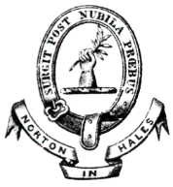
Chairman: Cllr P Eardley
Councillors: Cllr I Sadler, Cllr N Groom, Cllr S Moulson, Cllr B Cole, Cllr D Cliff
Clerk: Mrs M Joyce

Minutes of the Annual Parish Meeting held on 13th May 2024 at the Jubilee Hall, Norton in Hales

1 Welcome and Announcements
2 Present and/or Apologies
3 Minutes of the last Annual Parish Meeting 8th May 2024 – to receive
Prop
Sec
4 Matters arising from the Minutes
5 The Annual Report from the Parish Council
6 Public Questions in respect of above report
7 An opportunity for Members of the Parish to raise any matters for discussion

There being no further business for discussion, the Chairman declared the Meeting closed at 7:05pm thanking everyone for attending.

